Transmitter Setup Manual

1. 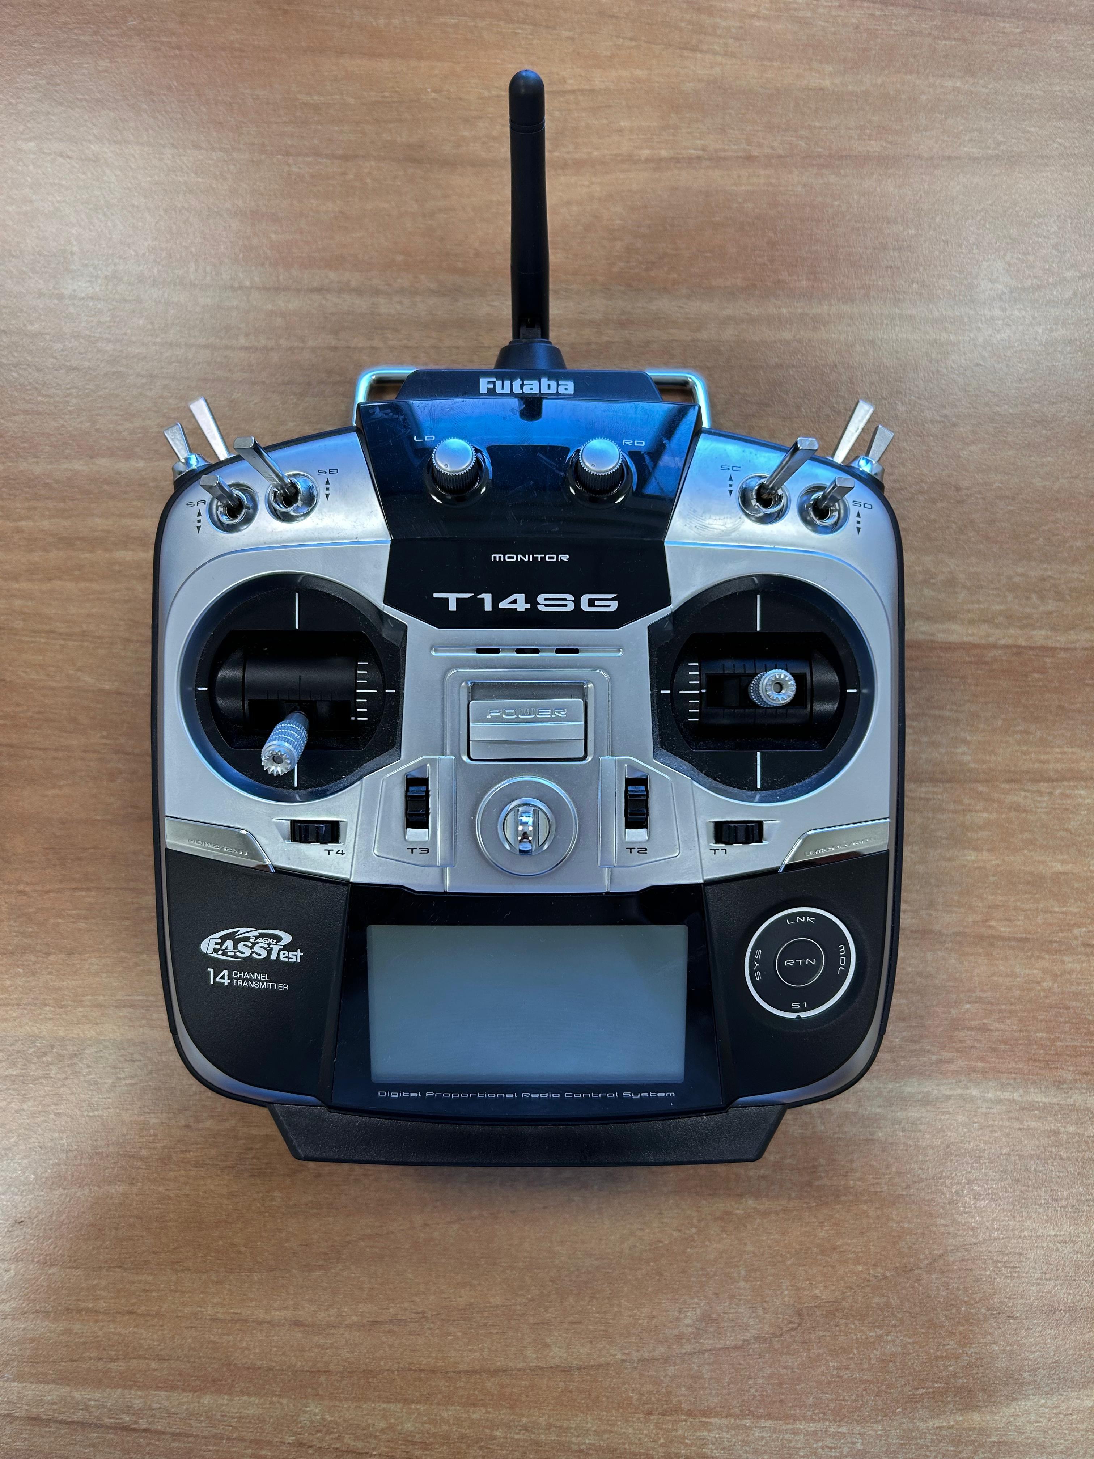Futaba T14SG

Turn on the transmitter by pushing this switch upwards

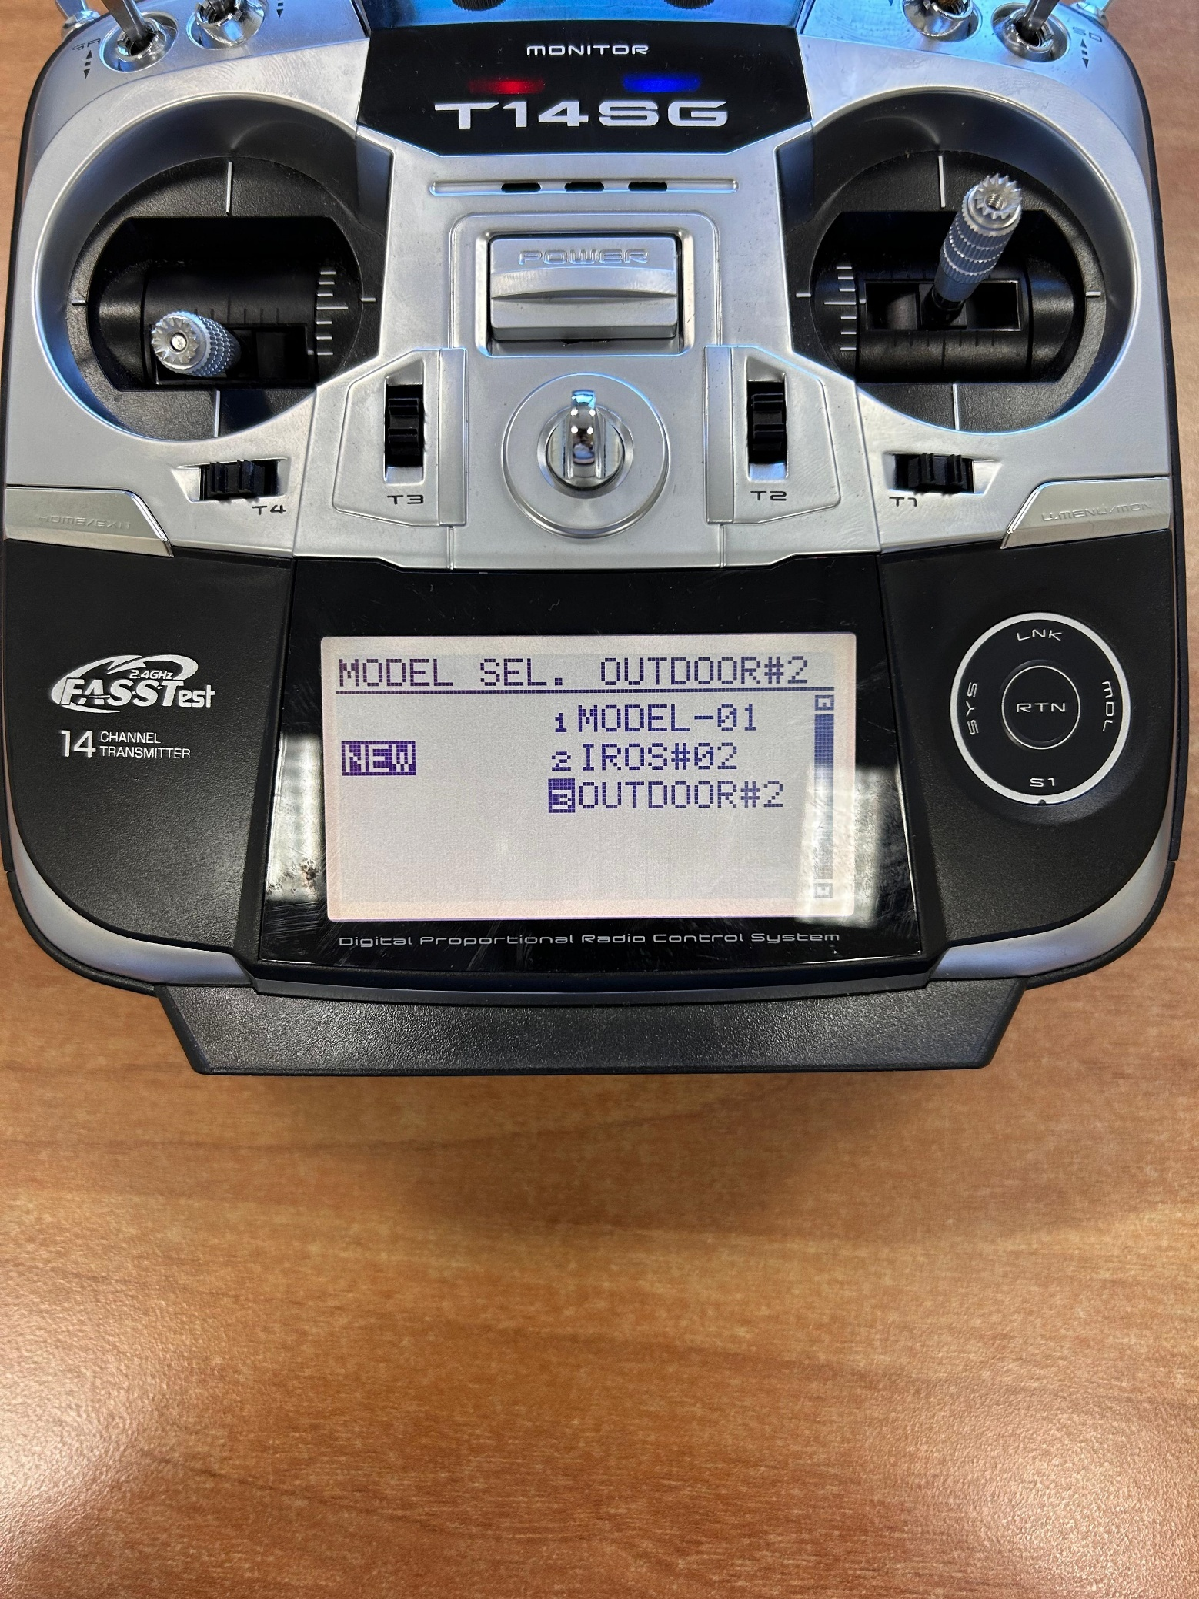

Scroll

Press

Select “New” by scrolling via the circular dial on the left.

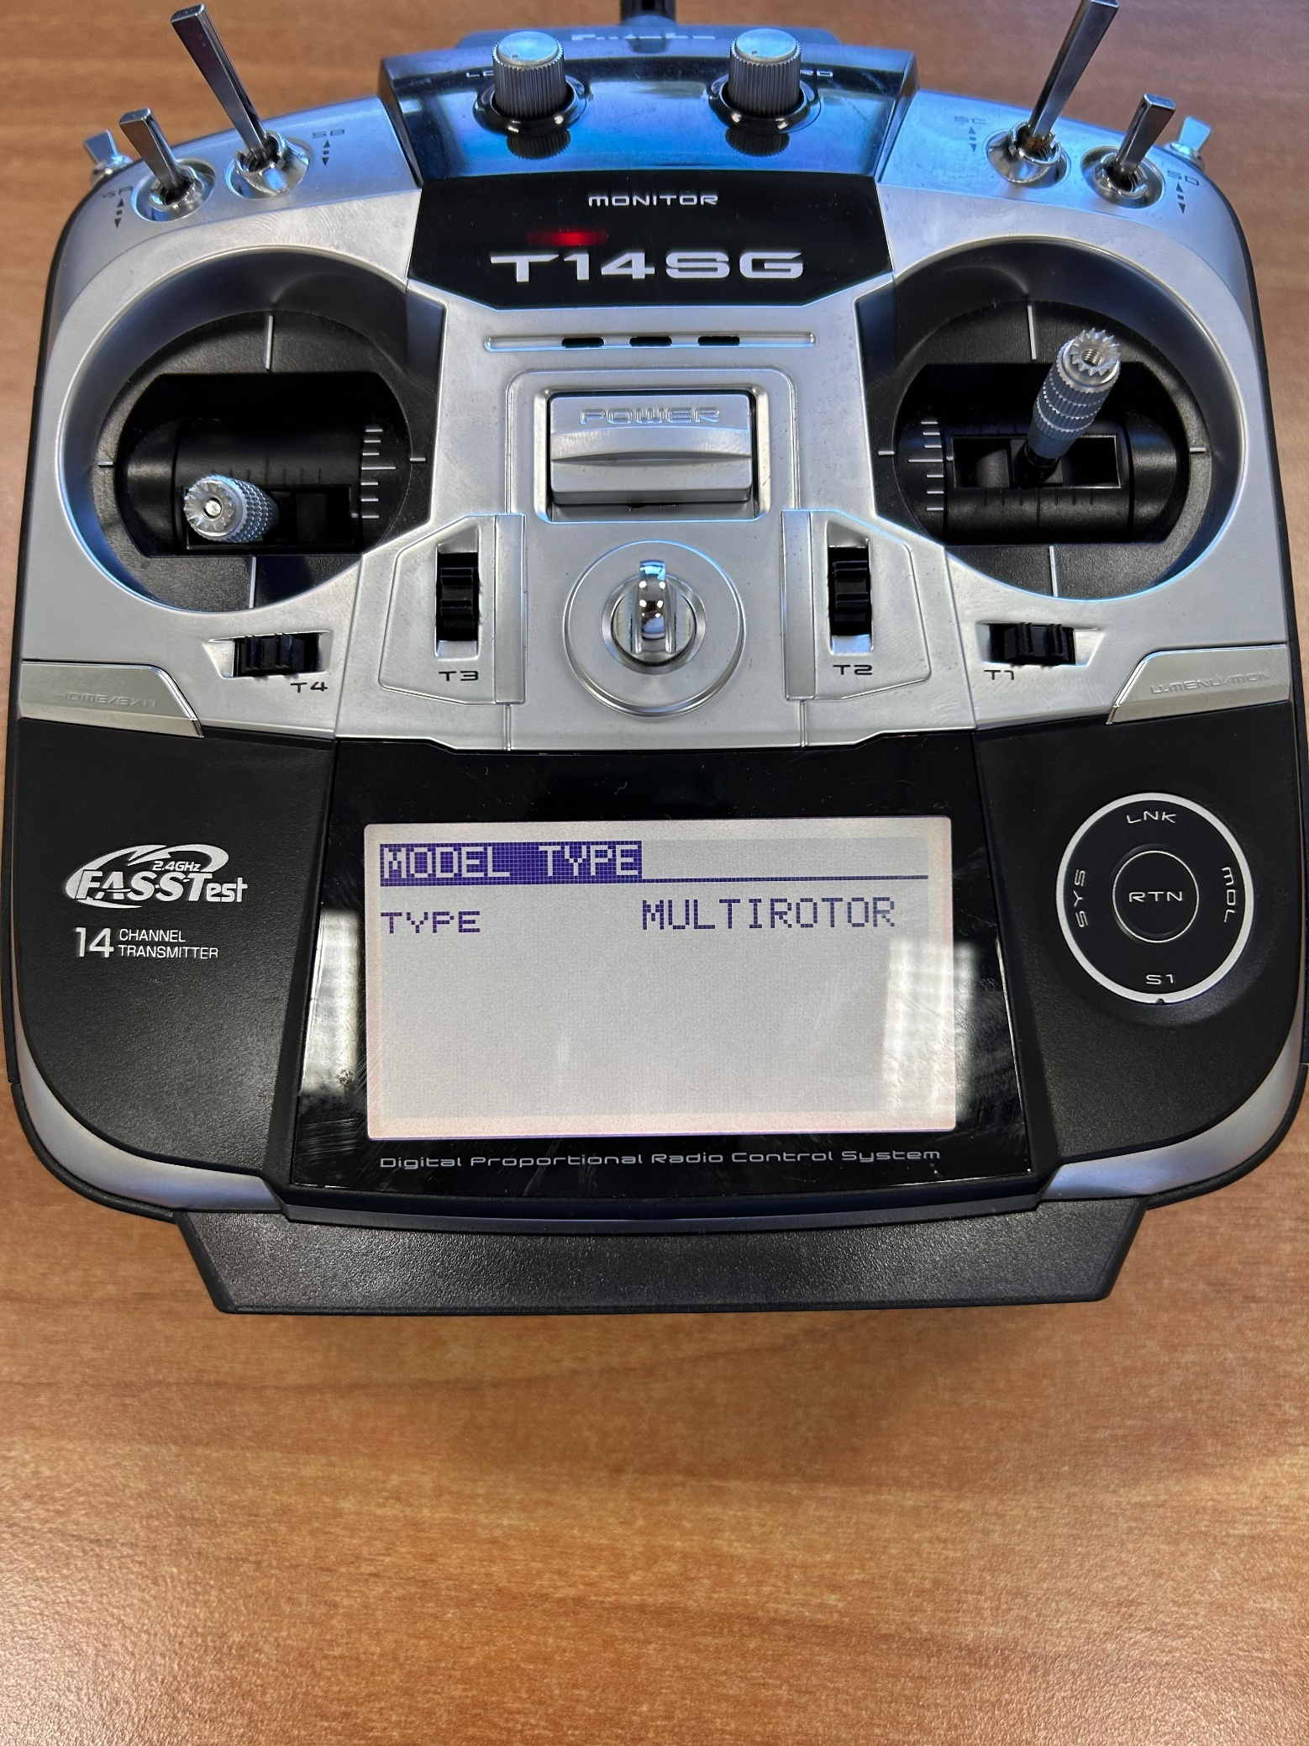

Press

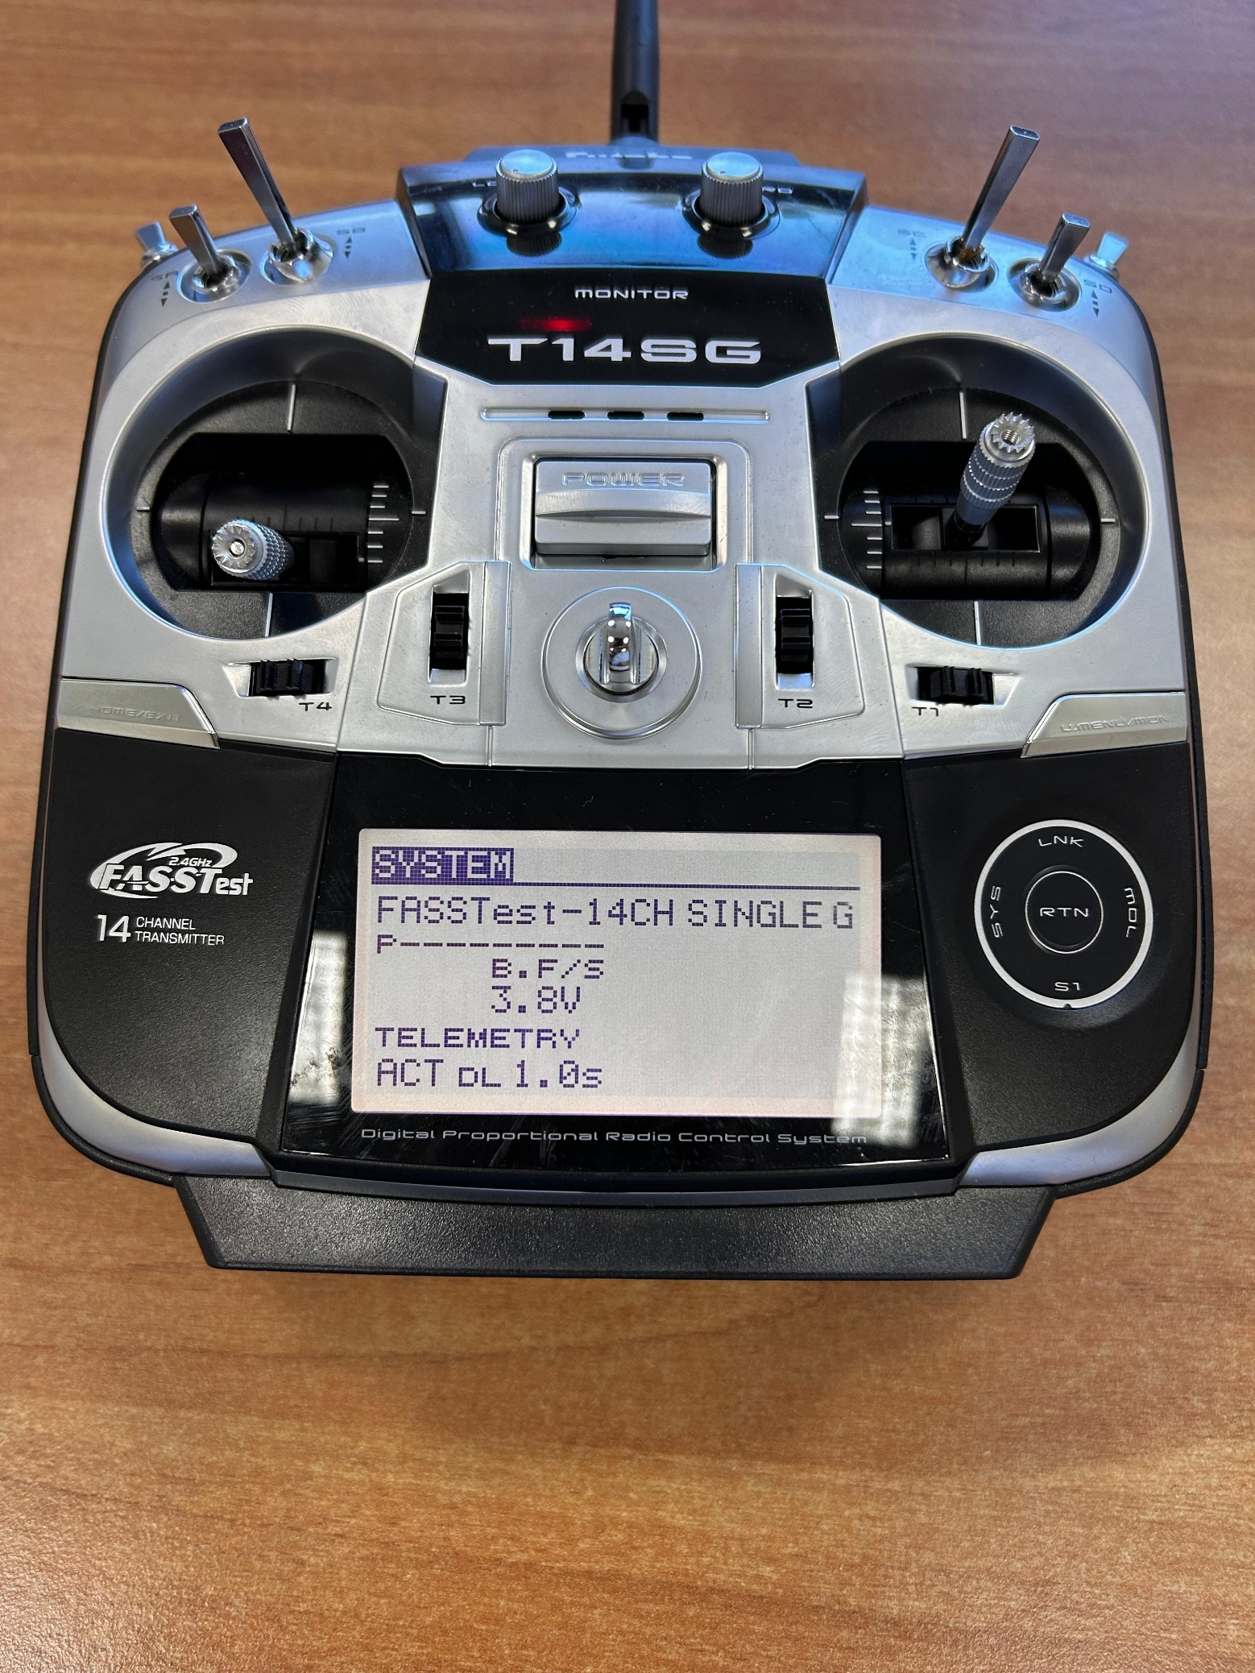

Press

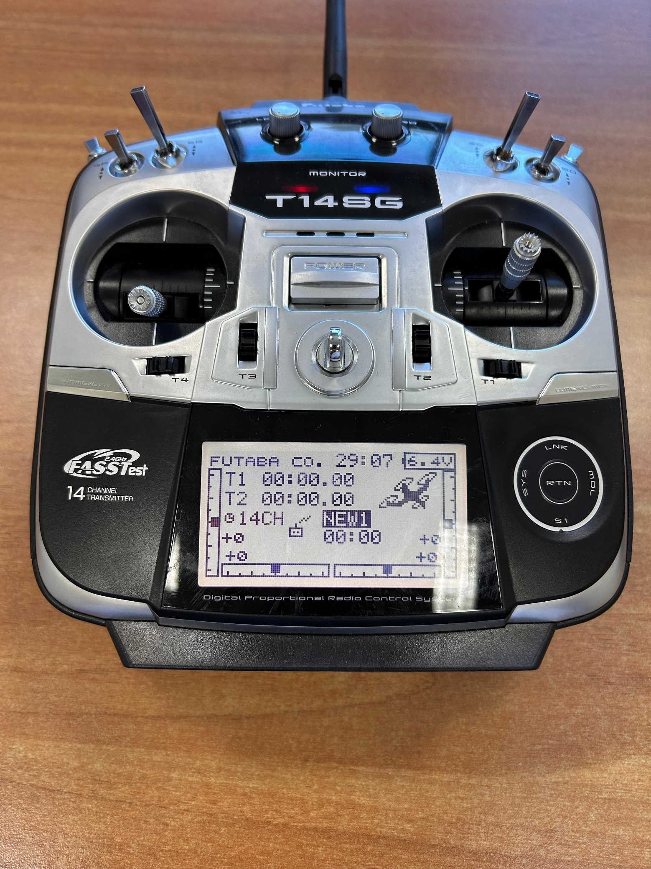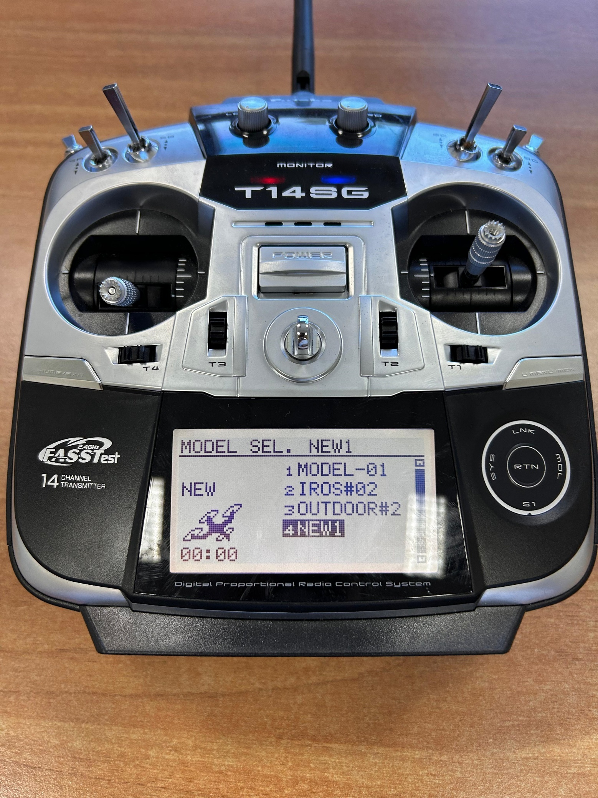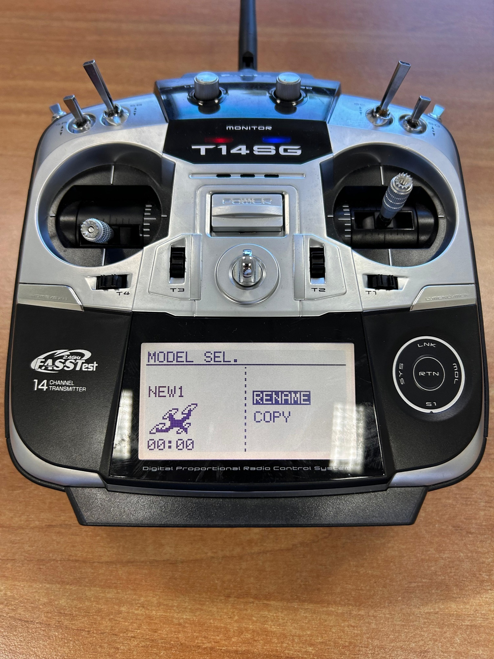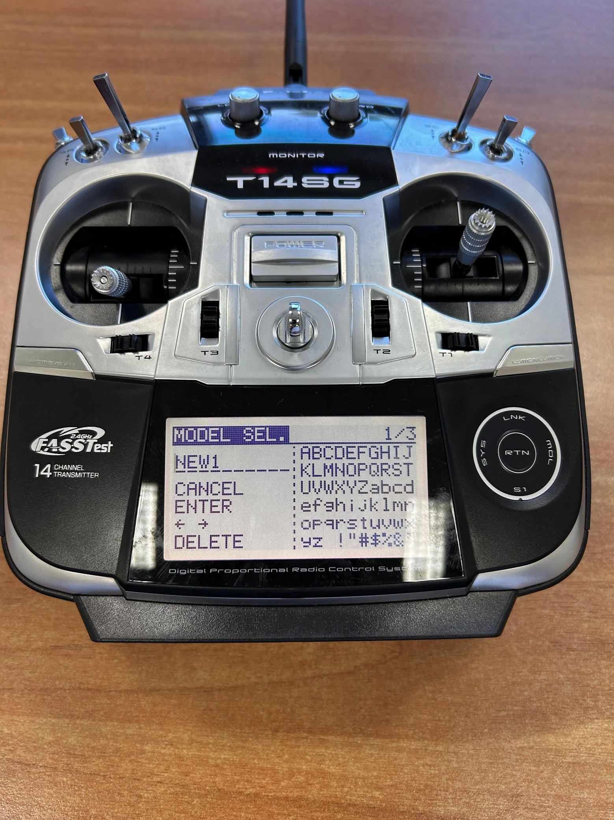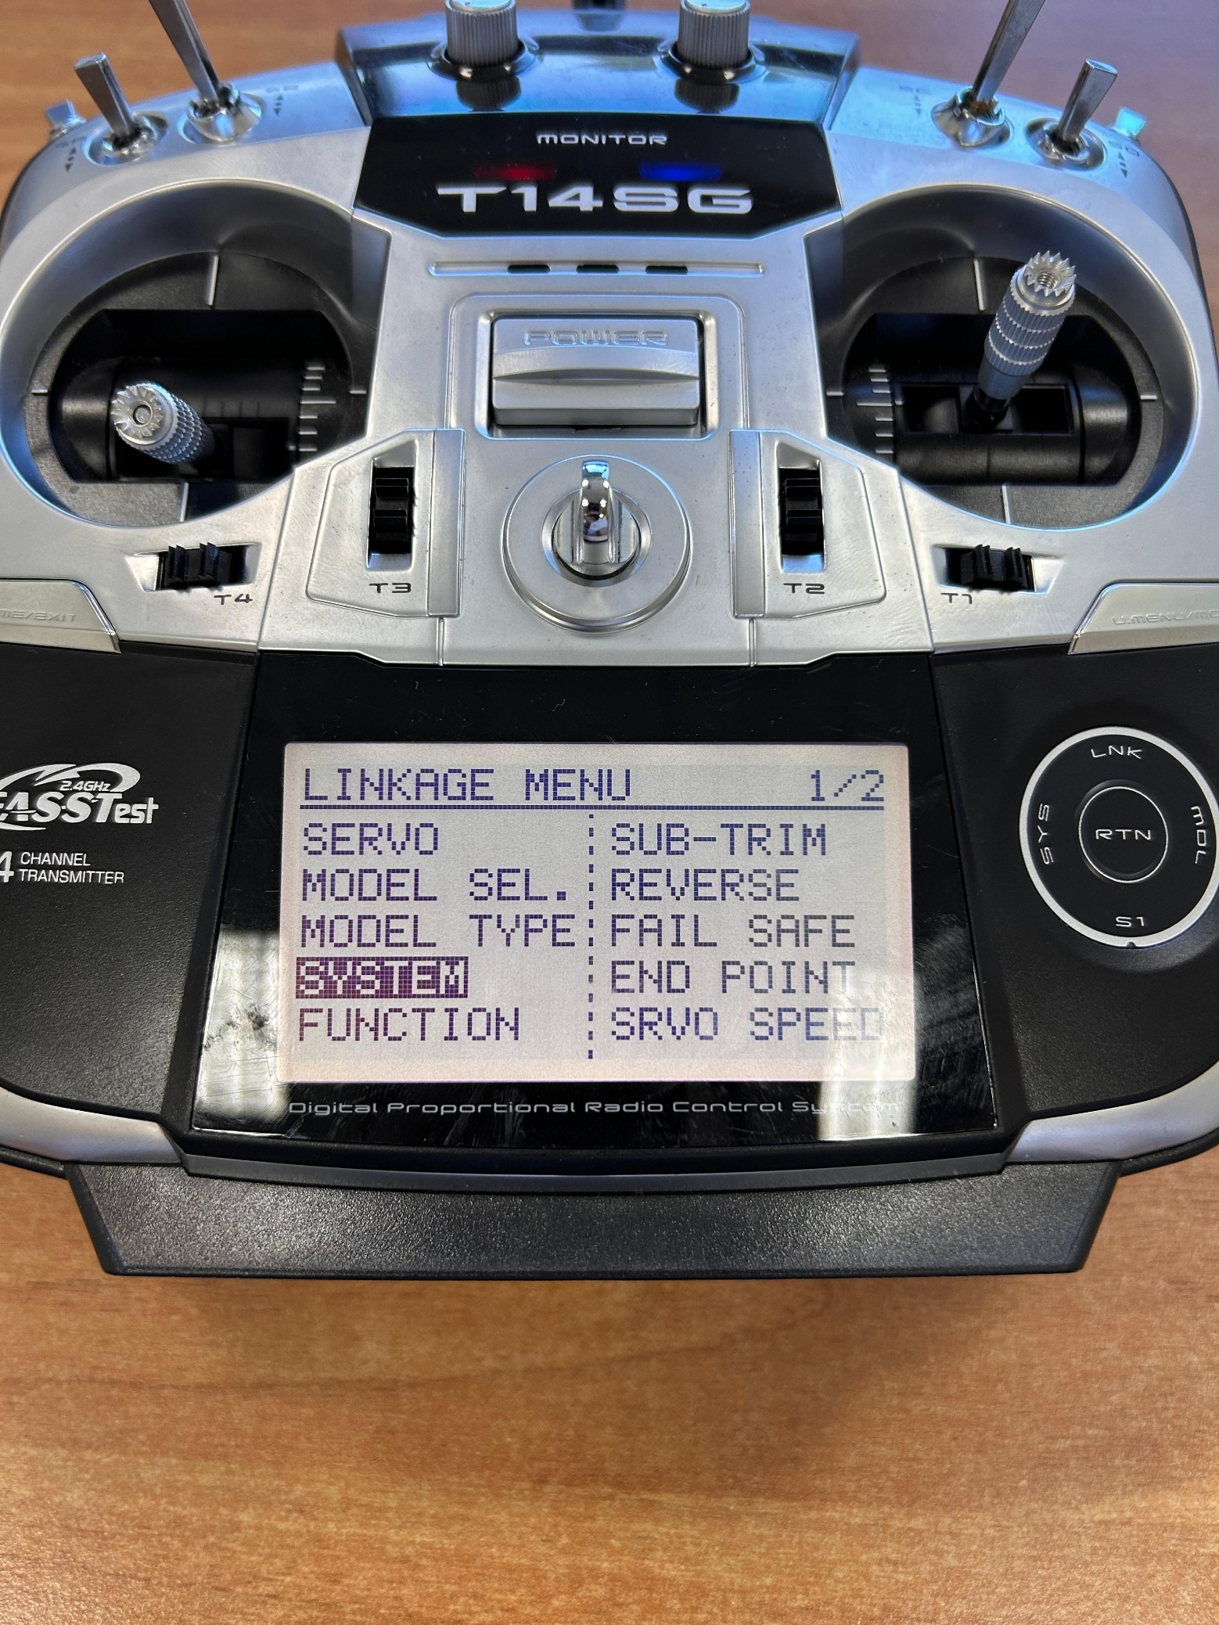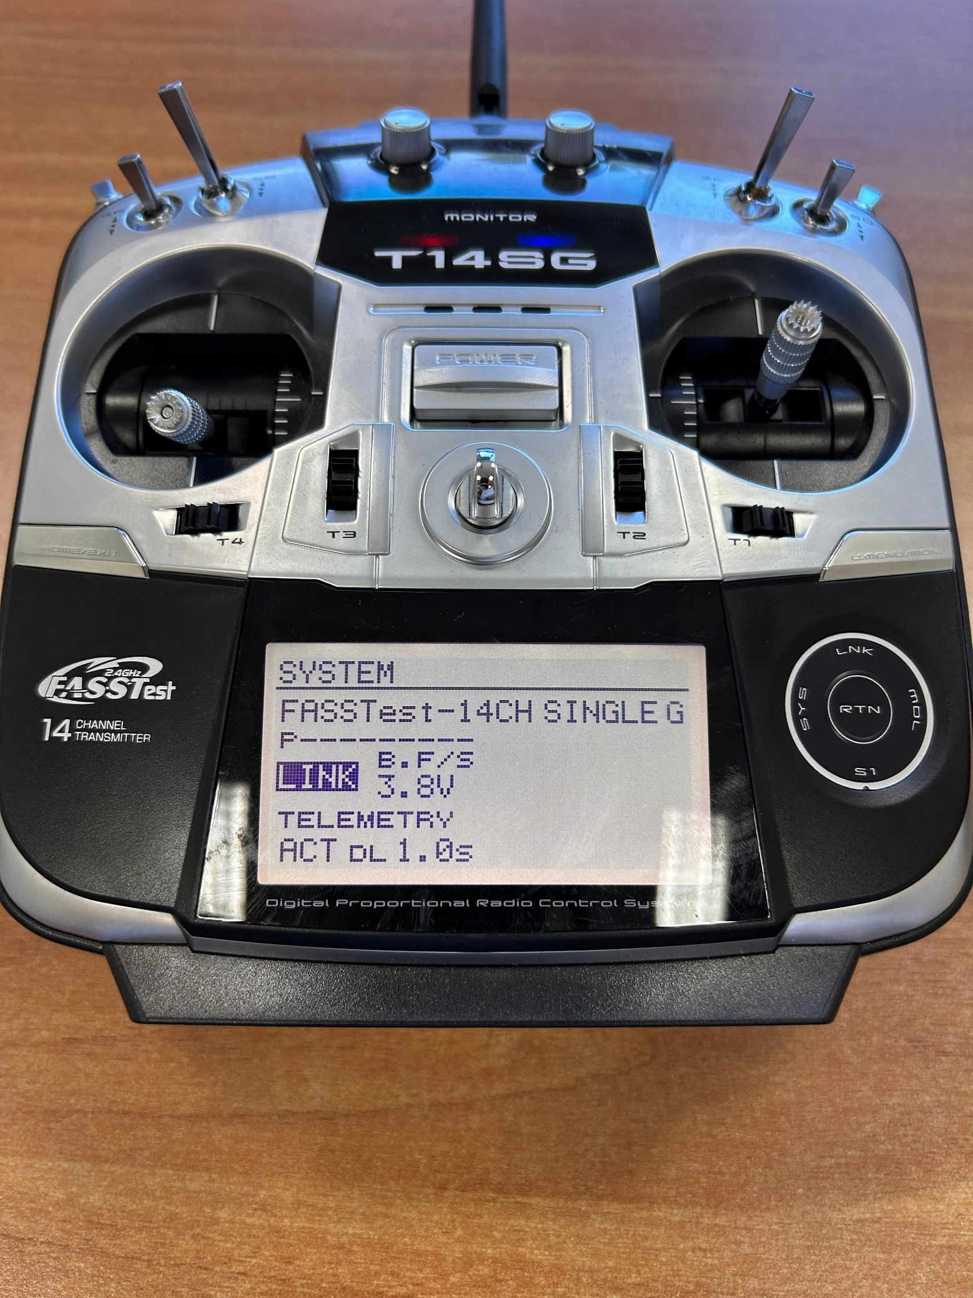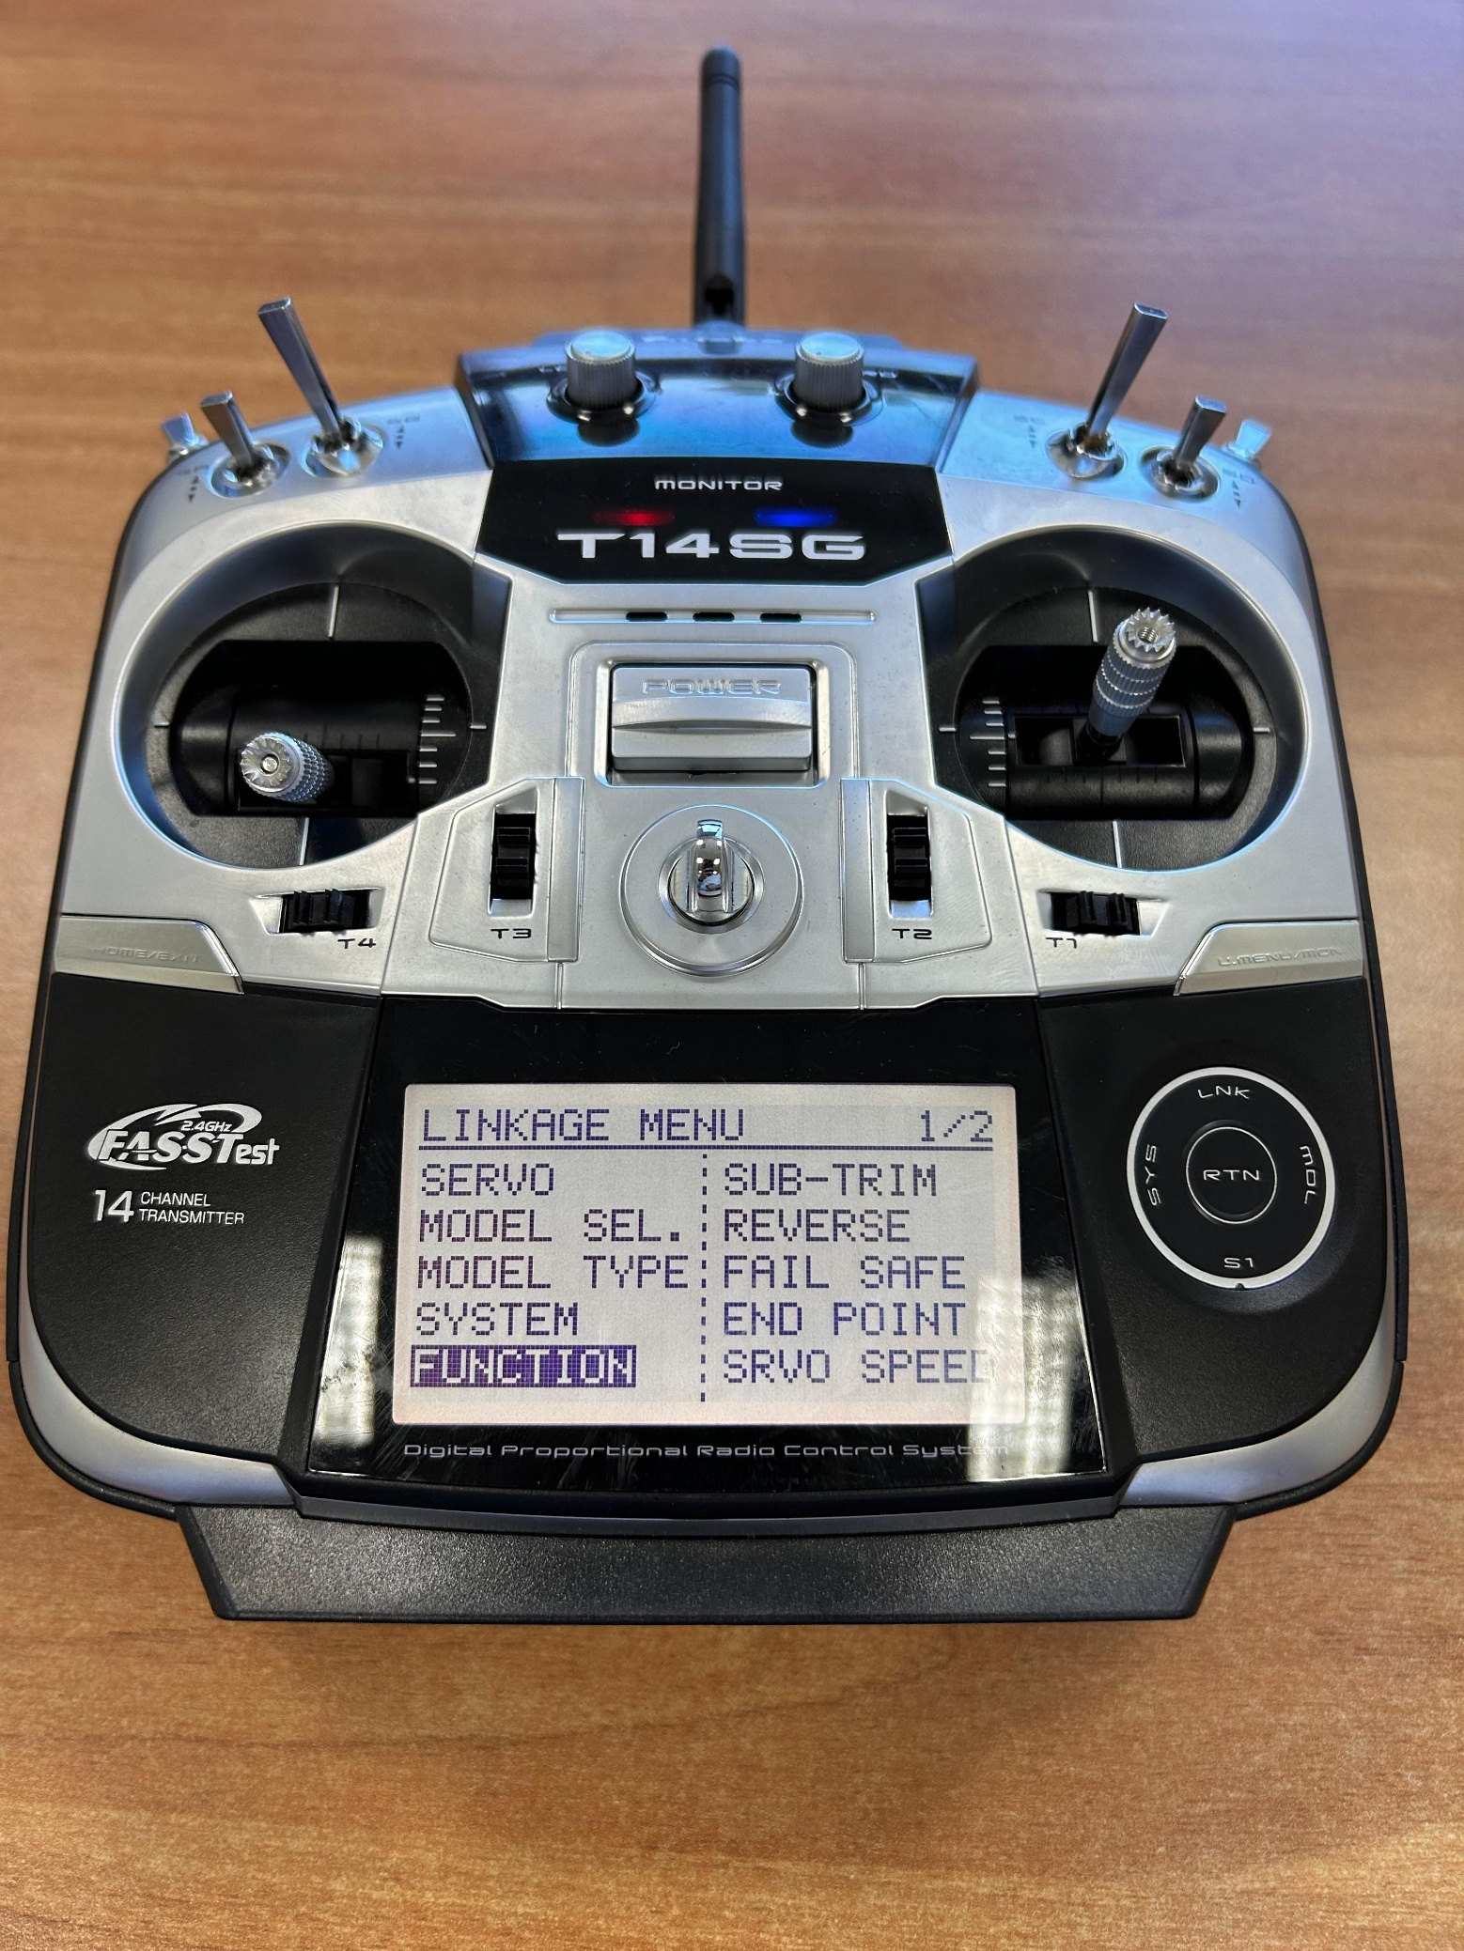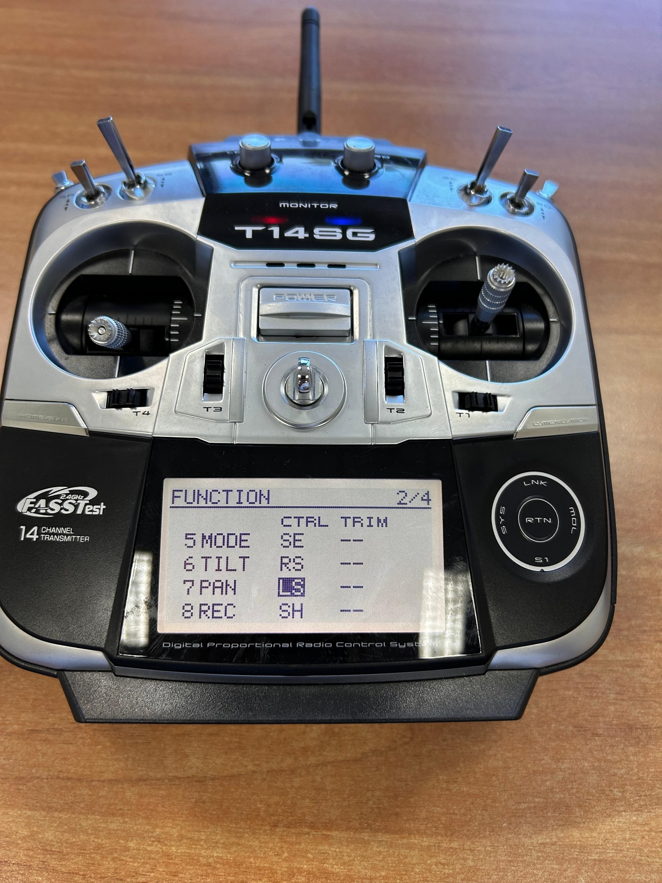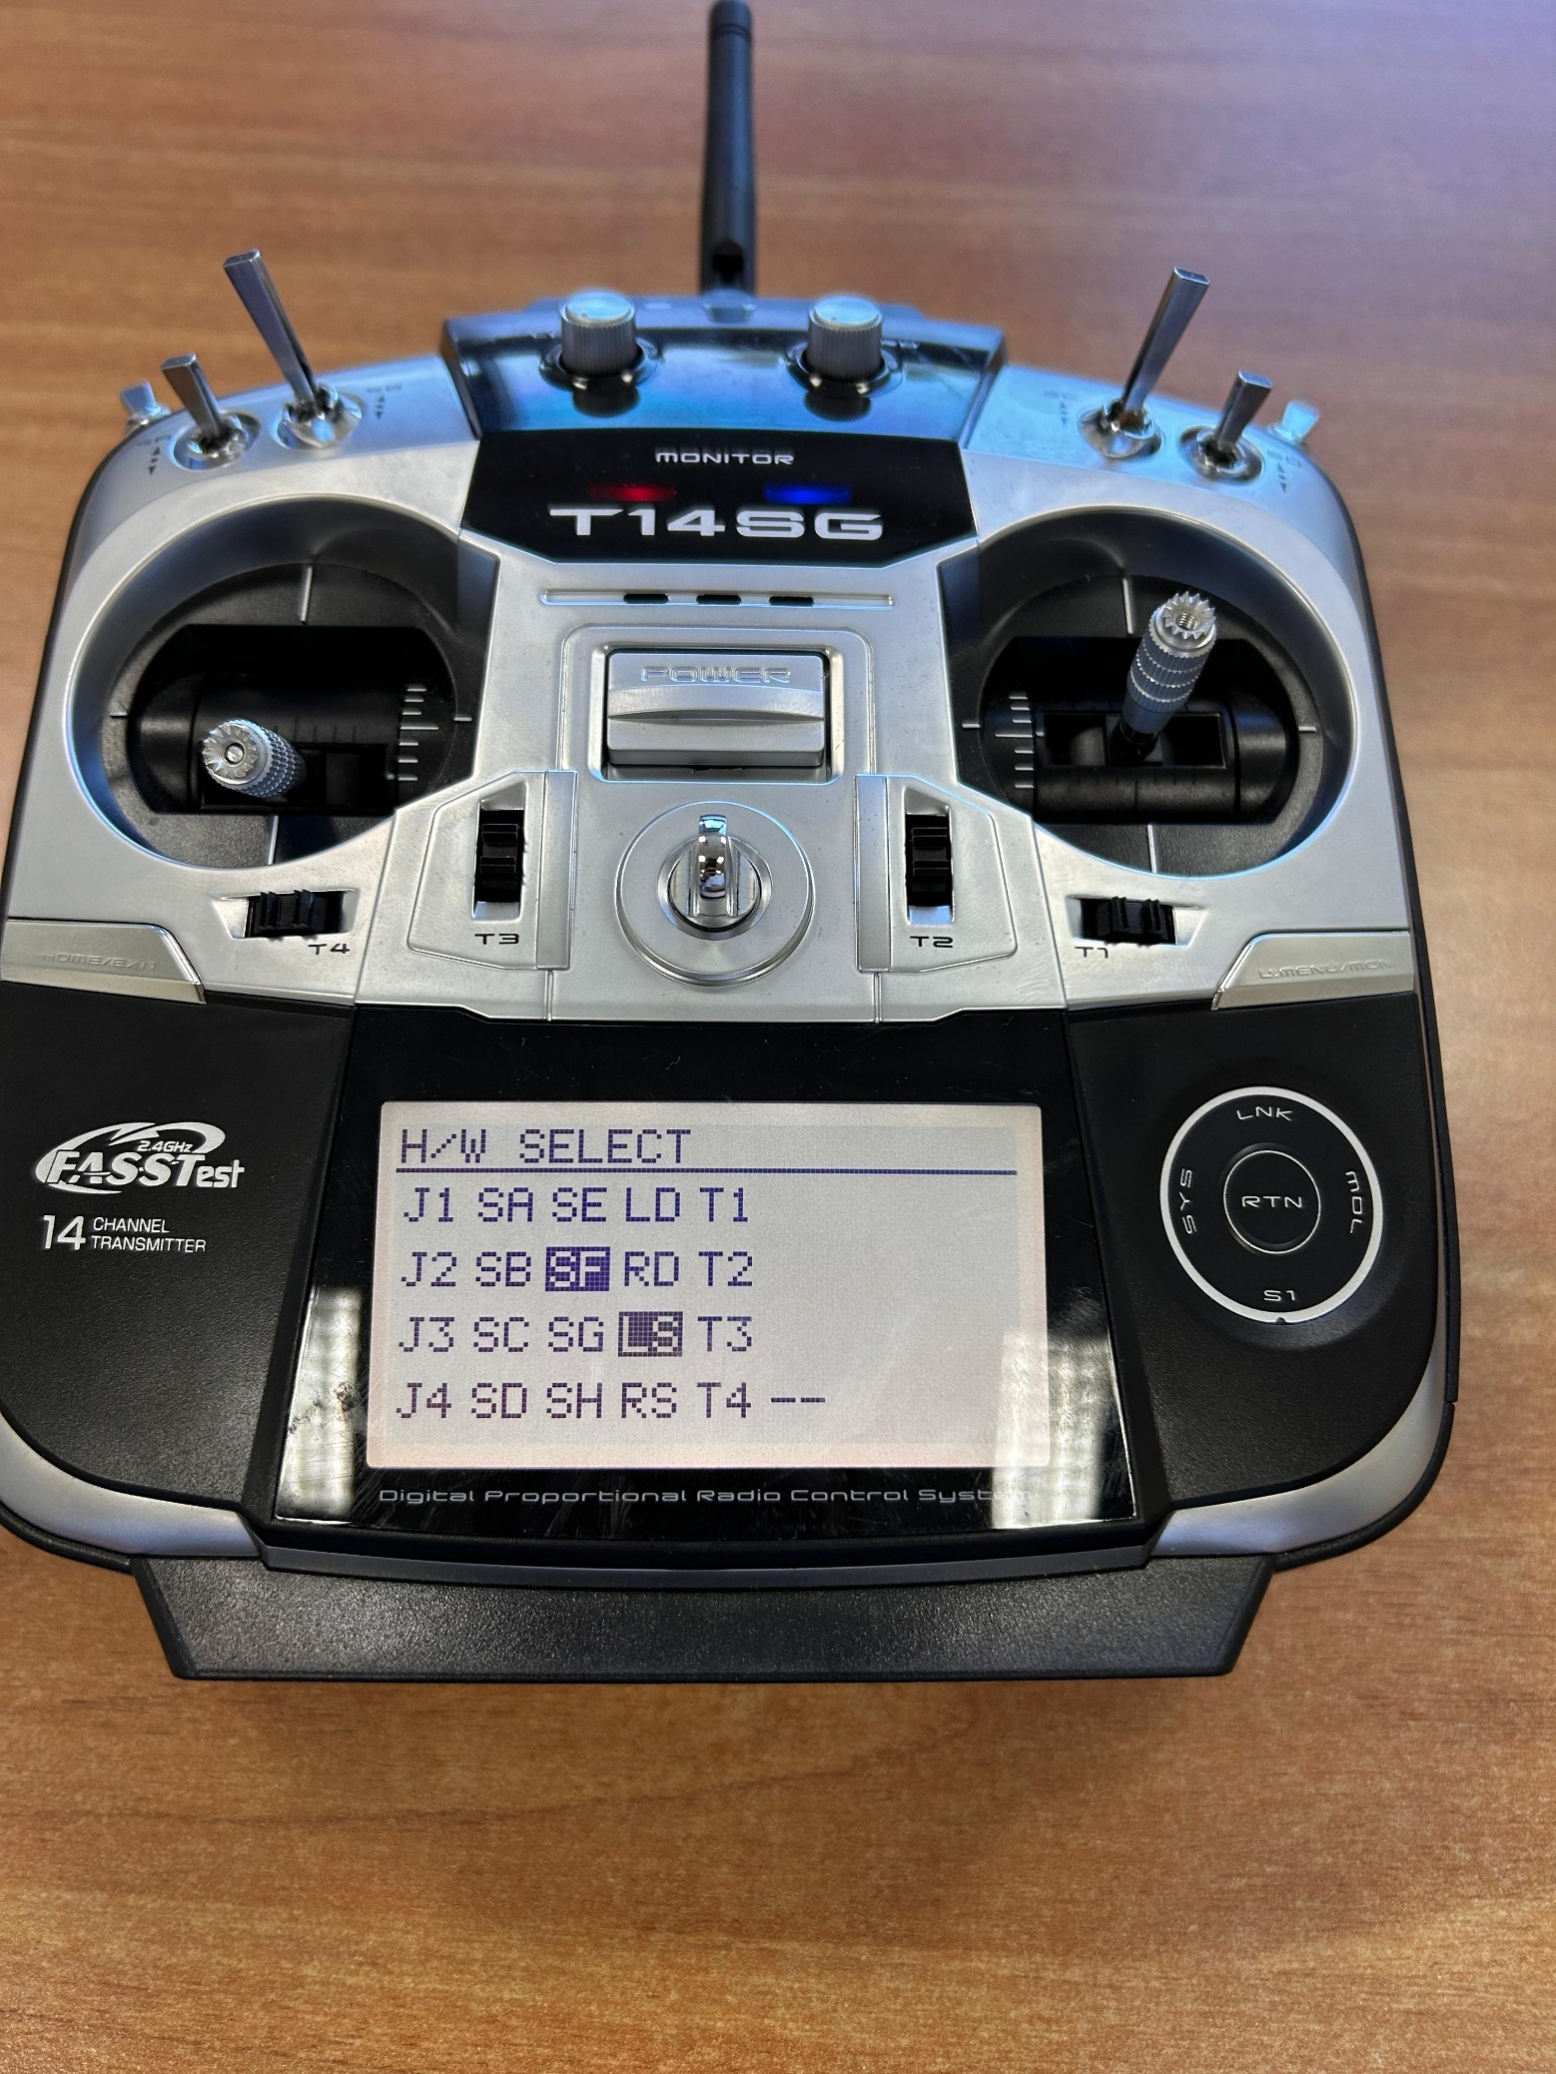

Scroll till this part is highlighted and press RTN on the dial.

Go to the new model you created and press RTN.

Choose RENAME.

Using the scroll wheel choose a new name for the model created earlier.

It is recommended that the name match the instance type of the drone.

Scroll down and choose SYSTEM.

After renaming, double tap on LNK to open the Linkage Menu.

Turn on the drone then press link. Once the transmitter stops beeping check the receiver on the drone. If it glows green that means it is bound, if it glows red redo this step.

In the linkage menu, scroll down and choose FUNCTION.

Scroll down to this selection next to the word PAN and press RTN.

Select SF

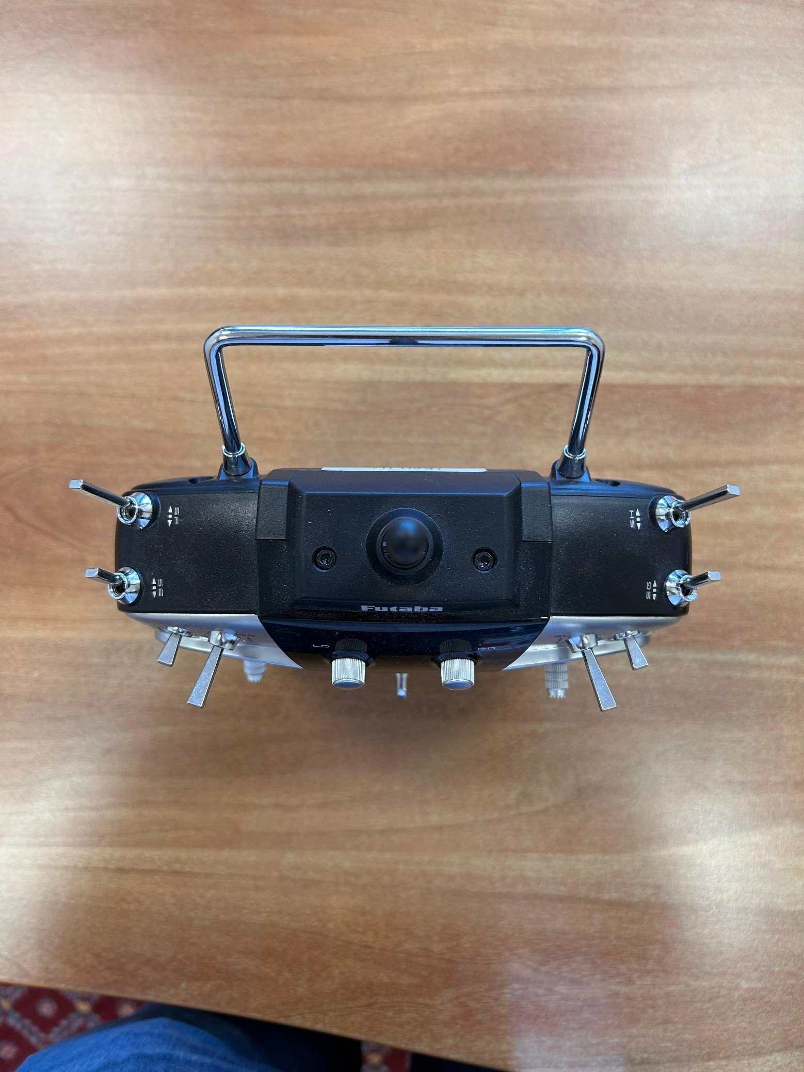

Now Channel 7 is bound to this switch on the transmitter. See QGC Setup to encode the Kill-Switch function to it.

1. 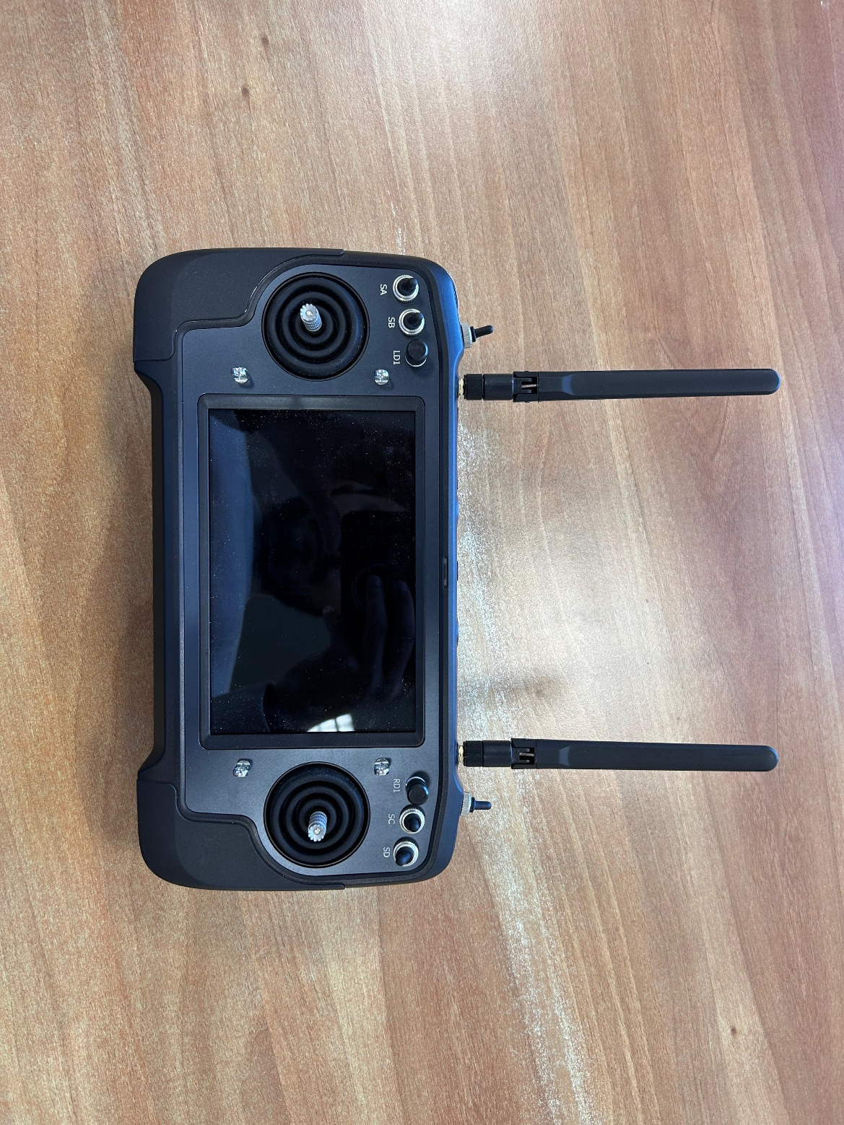SiYi M32 Handheld Ground Station

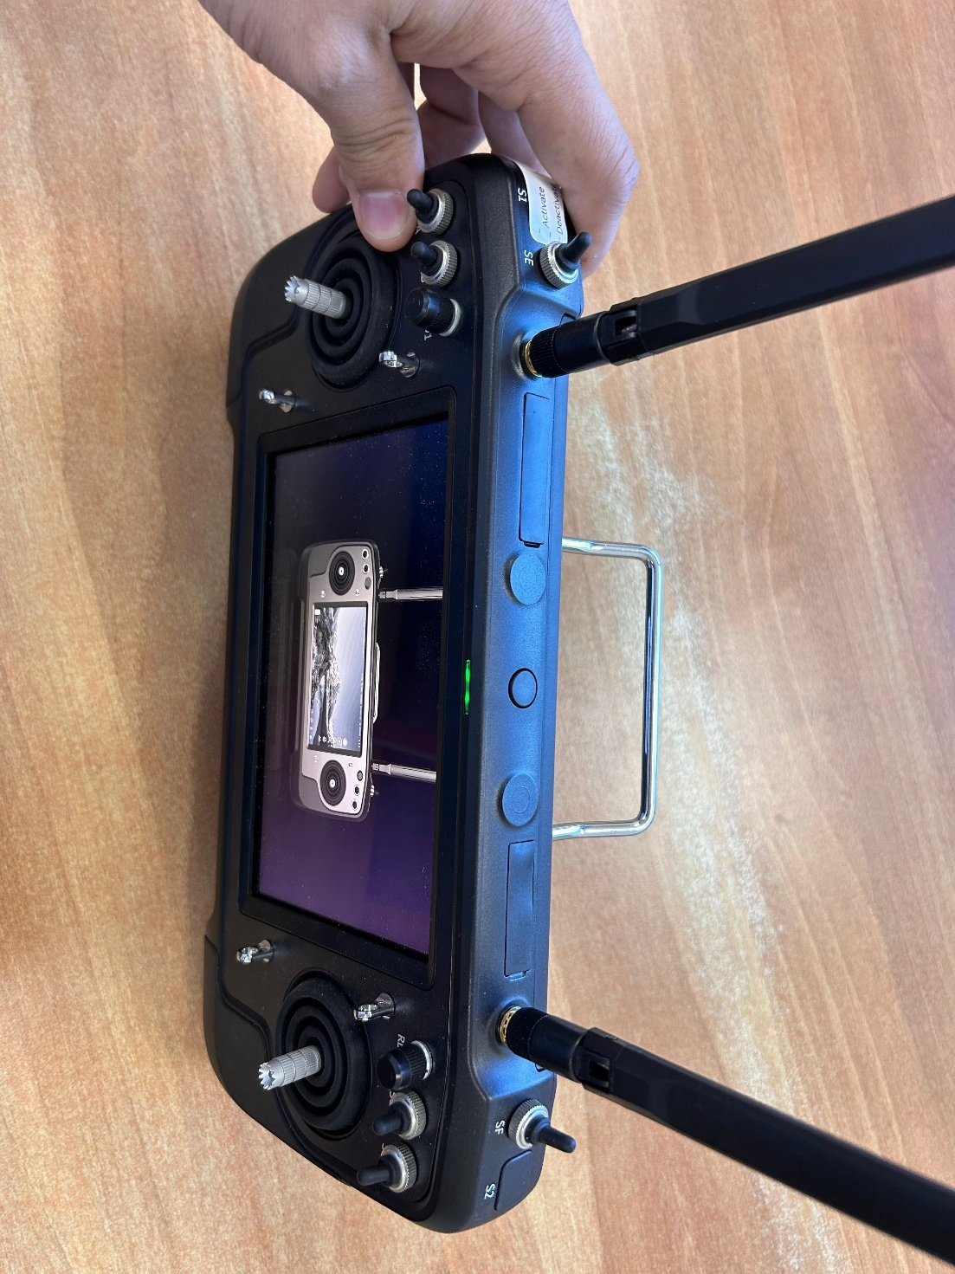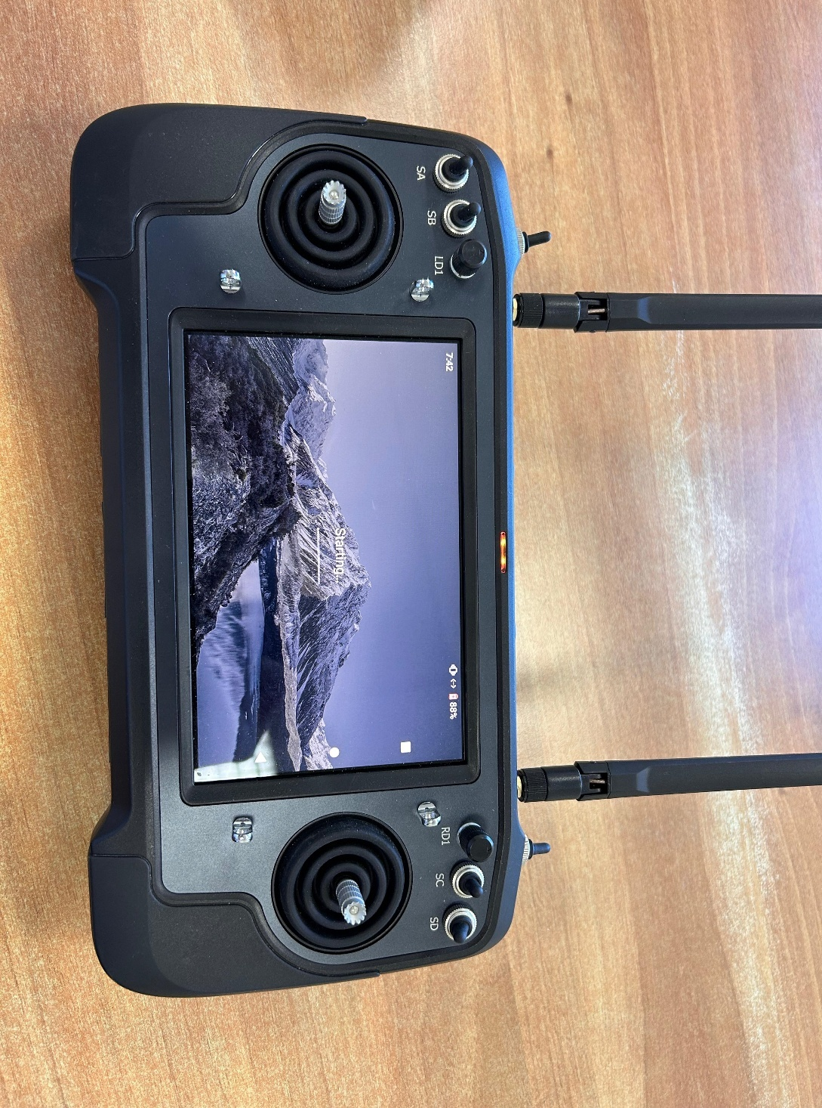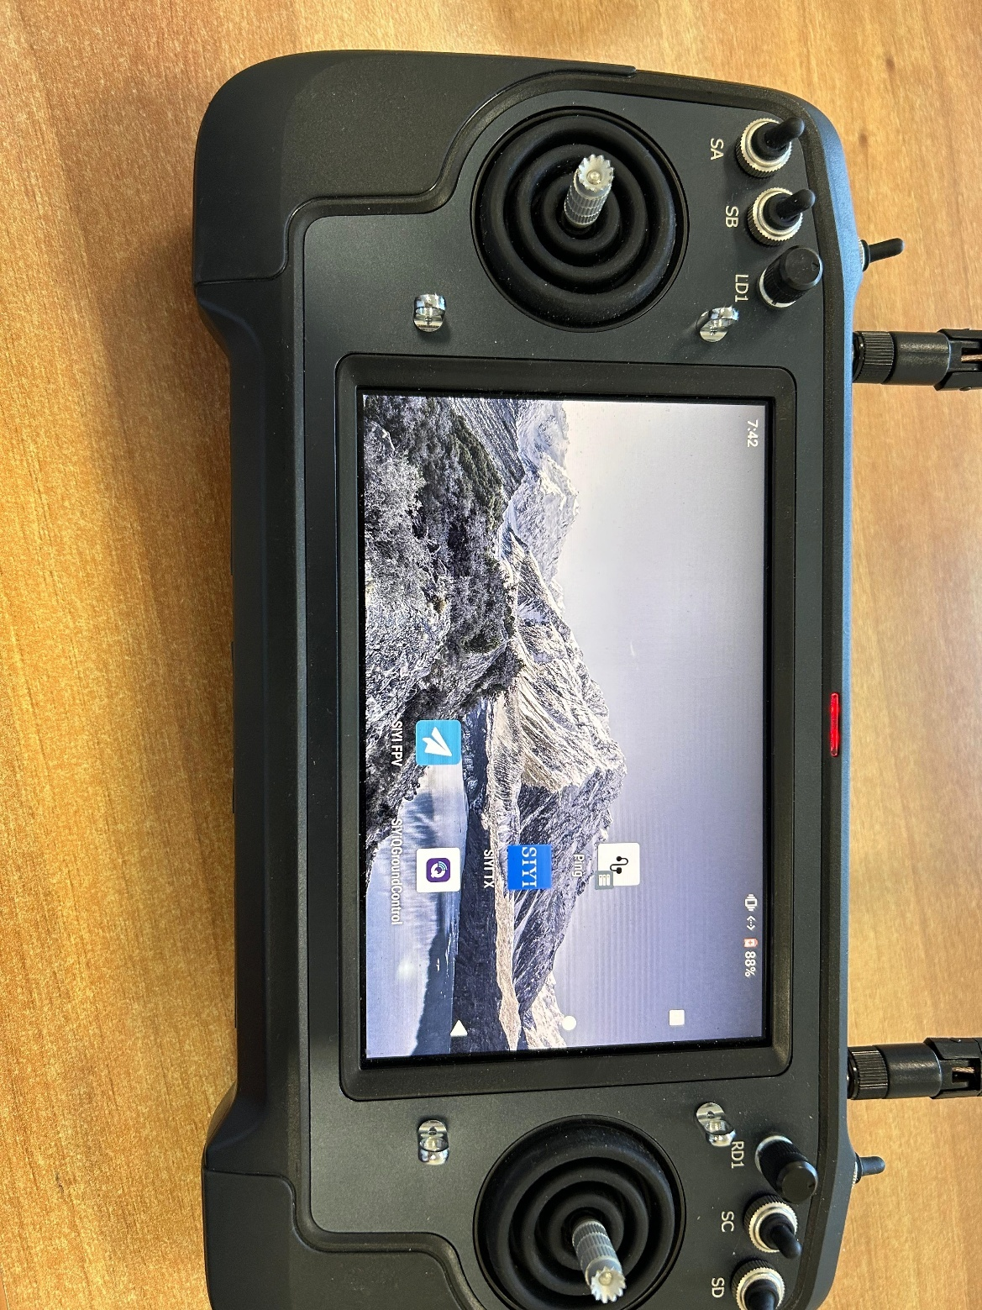

Turn on the transmitter by pressing on the button found here. Press one short press and one long press.

Tap on this application

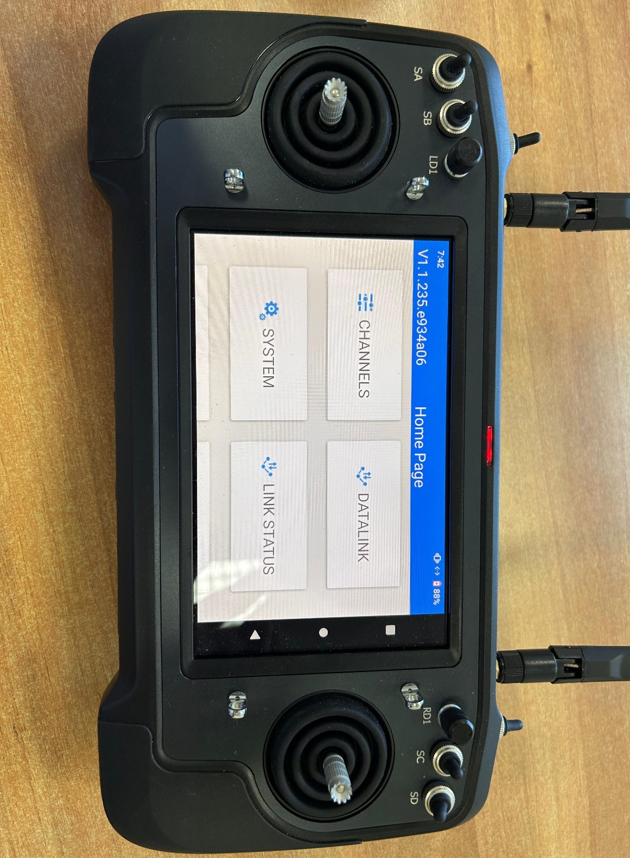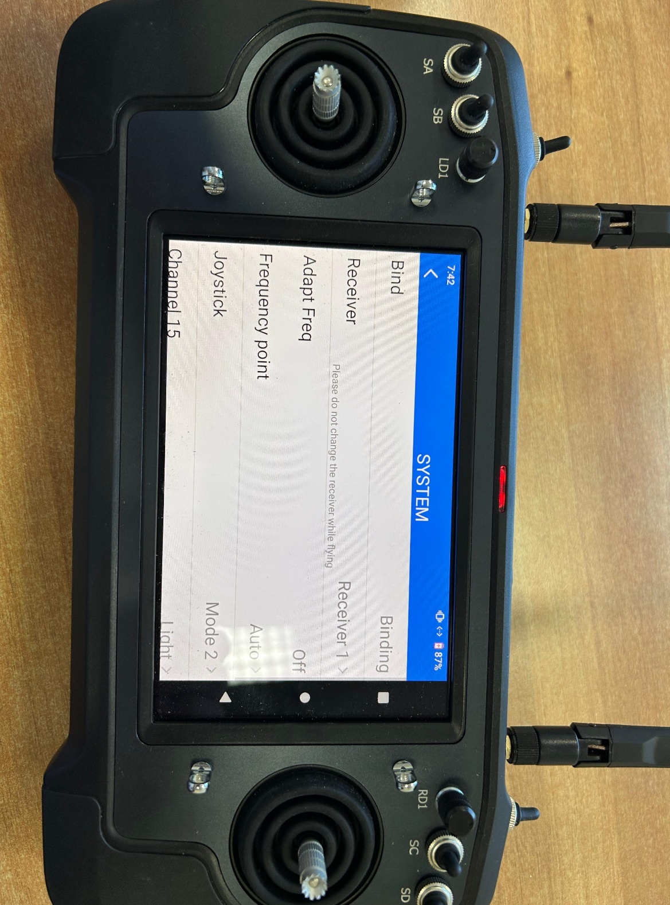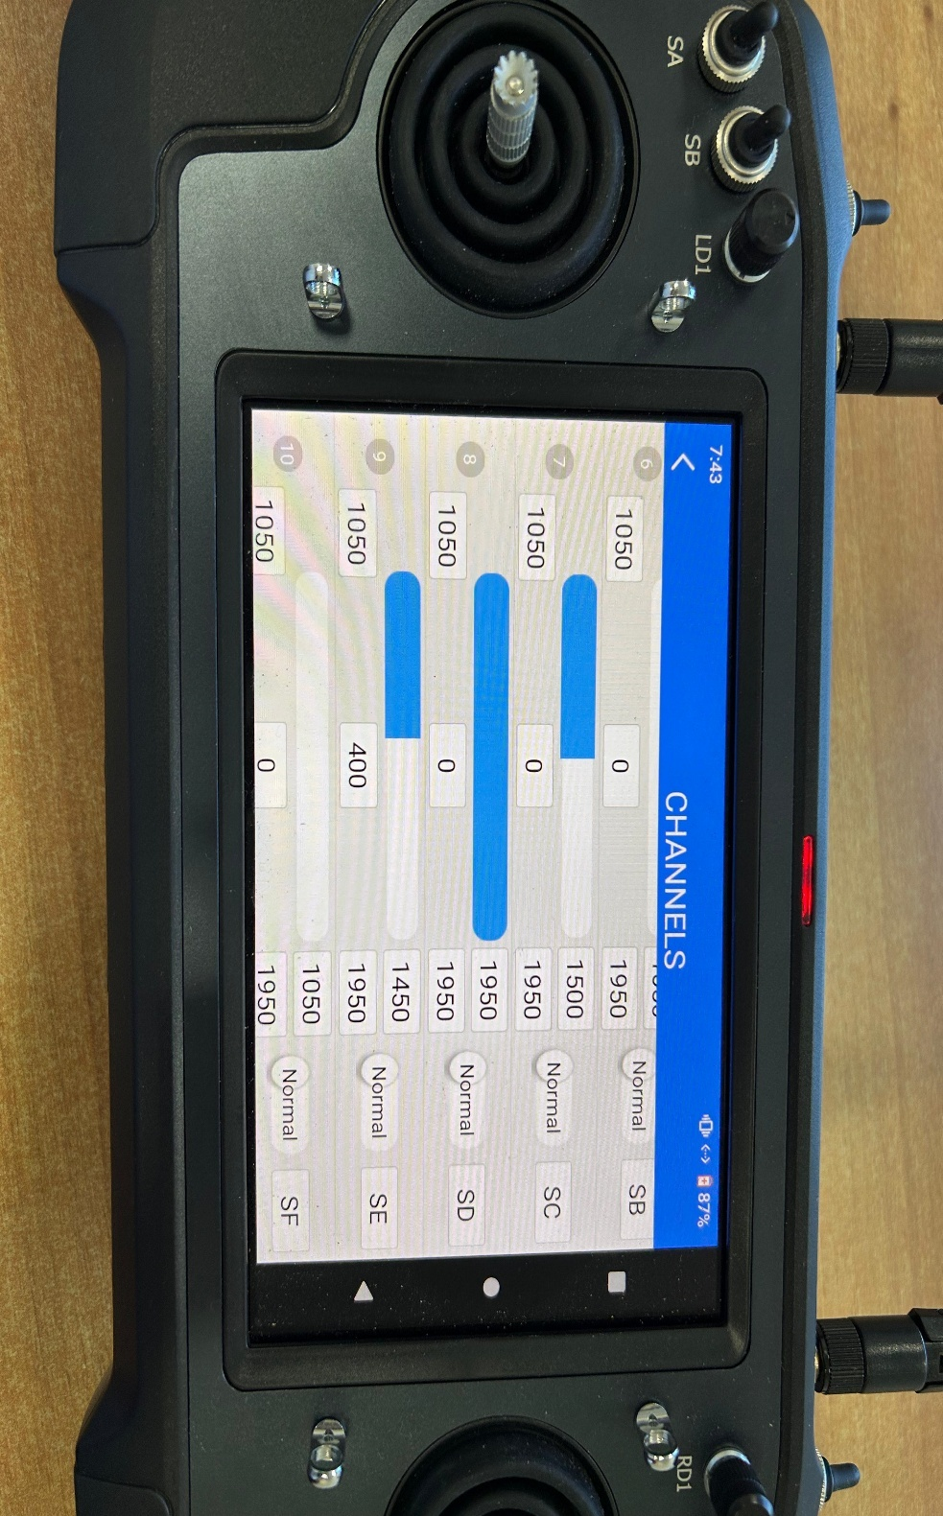

Tap on Bind and wait until Binding turns into bound.

Tap on SYSTEM

Go back to the Home Page and press CHANNELS.

Tap here and choose SE.

1. QGroundControl Setup

In QGC go to the Vehicle Setup Menu.

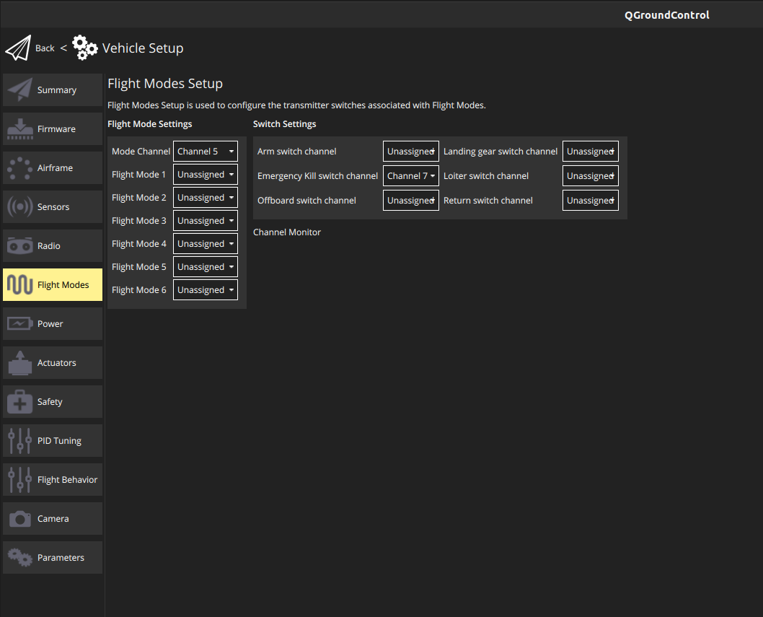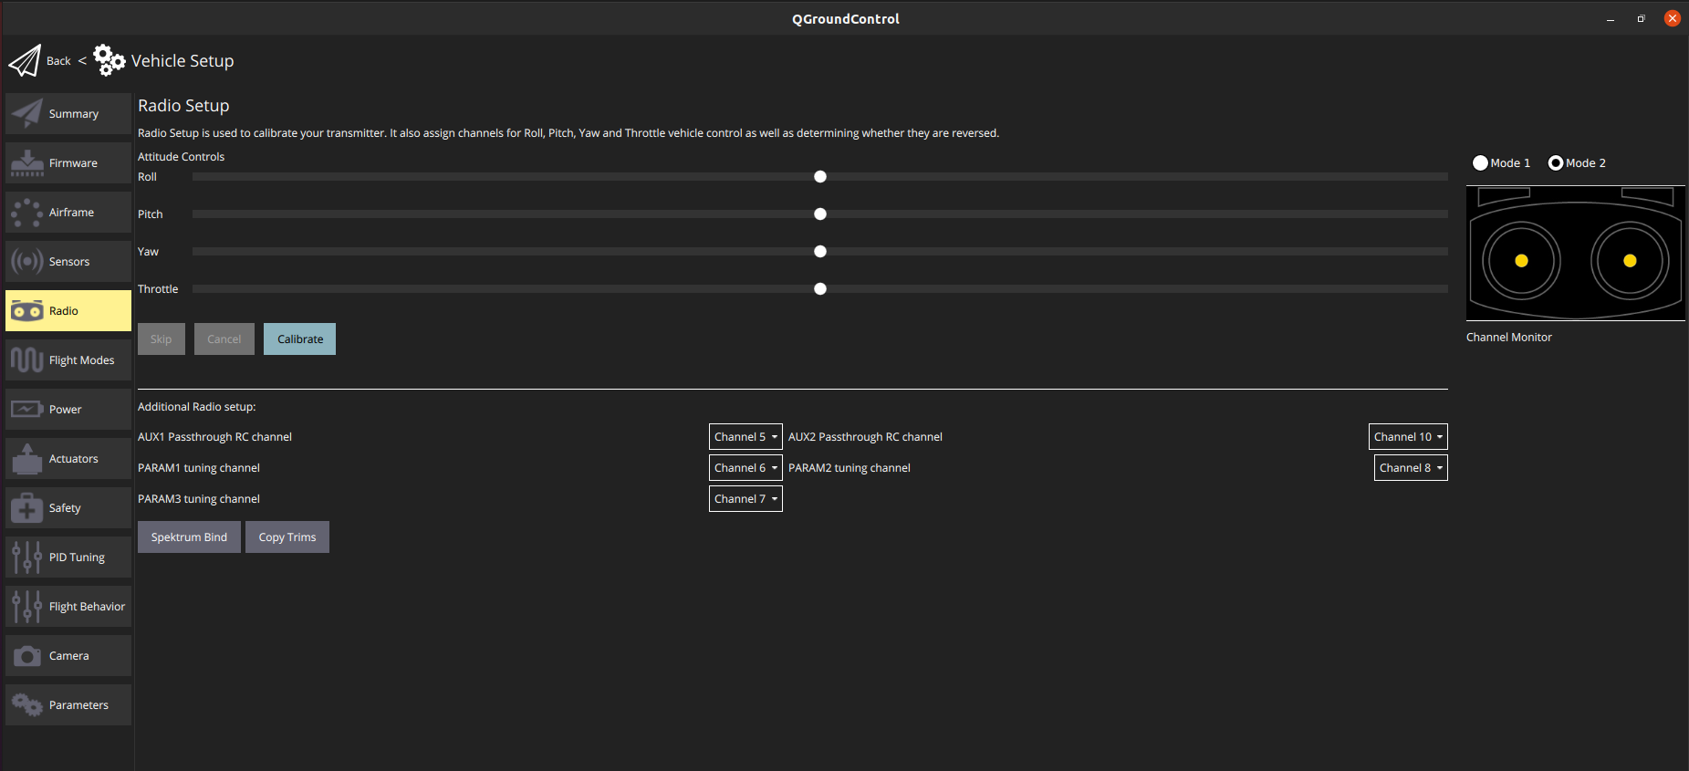

Set the Emergency Kill Switch Channel to Channel 7

Go the Flight Modes Tab

Go the Radio Tab

Press Calibrate and follow the instructions.